PILGRIM CELLO FOR LENT
ST MARY MAGDALENE BRIDGNORTH
Saturday 7TH March 2026 2.00pm

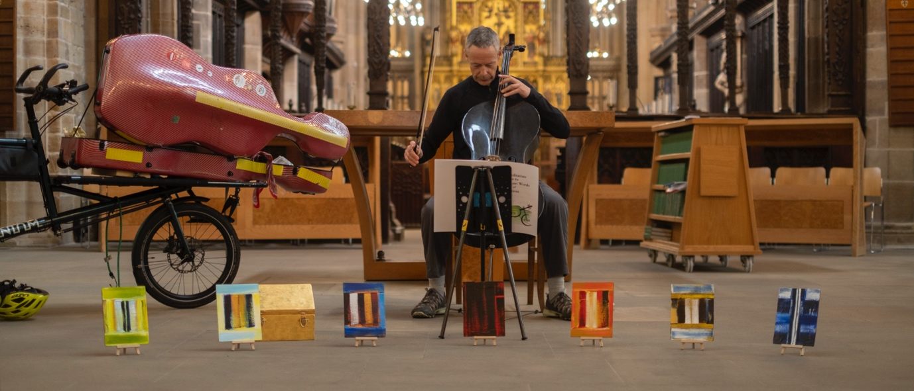

"Kenneth Wilson tells the story of a unique journey - a 1,900 mile bicycle pilgrimage around England's 42 cathedrals, with his cello, performing a Meditation on the Seven Last Words of Jesus in 41 of them. Come and hear his music, and his story. 'Left us spiritually transformed,' (The Very Revd Dr Simon Jones, Dean of Lincoln)."

A two-set performance, with the Meditation itself, followed by a musical account of the pilgrimage.
Ticket price £12 on the door

