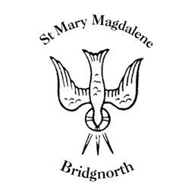

Sunday Services

Sunday 26th October
10.30am Family/Baptism Service
Led by Revd. Suzan Williams

NEXT WEEK

Wednesday 29th October
10.30am Morning Prayer
Led by Revd. Suzan Williams

St Mary’s Church Choir practice 6.00pm -7.00pm
St Mary’s singing group practice – 7.00pm – 8.00pm

Saturday 1st November
Christmas Fayre 11.00am-2.00pm

www.bridgnorthteamministry.org.uk

