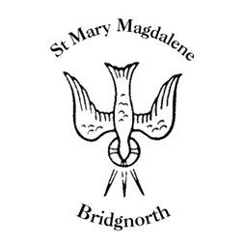

Sunday Services

Sunday 19th October
10.30am Morning Prayer
Led by David Oxtoby

6.00pm Service of Remembrance
Led By Revd. Suzan Williams

Monday 20th October
11.00am Thanksgiving Service for the late Lady Corinna Hamilton of Dalziel

NEXT WEEK

Wednesday 22nd October
10.30am Morning Prayer
Led by Revd. Simon Boxall

St Mary’s Church Choir practice 6.00pm -7.00pm
St Mary’s singing group practice – 7.00pm – 8.00pm

Thursday 23rd October
10.00am Little Stars

www.bridgnorthteamministry.org.uk

