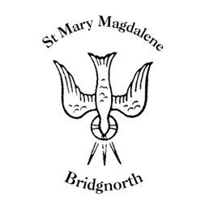

Sunday Services

Sunday 5th October
10.30am Holy Communion
Led by Revd. Suzan Williams

NEXT WEEK

Wednesday 8th October
10.30am Holy Communion
Led by Revd. Suzan Williams

Thursday 9th October
10.00am Little Stars
6pm Bridgnorth Endowed Presentation Evening

25th September – 7th October
Knitted Bible Exhibition

www.bridgnorthteamministry.org.uk

