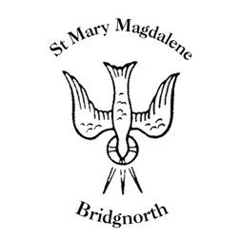

Sunday Services

Sunday 21st September
10.30am Morning Prayer
Led by Revd. David Oxtoby

NEXT WEEK

Wednesday 24th September
10.30am Holy Communion
Led by Revd. Suzan Williams

Thursday 25th September
10.00am Little Stars

25th September – 7th October
Knitted Bible Exhibition

www.bridgnorthteamministry.org.uk

