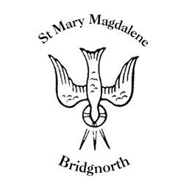

Sunday Services

Sunday 14th September
10.30am Holy Communion
Led by Revd. Suzan Williams

NEXT WEEK

Friday 12th – Monday 15th September
Glass Exhibition

Wednesday 17th September
10.30am Holy Communion
Led by Revd. Suzan Williams

Thursday 18th September
10.00am Little Stars

Saturday 20th September
4.00pm Daddy’s Hat classical guitar concert

www.bridgnorthteamministry.org.uk

