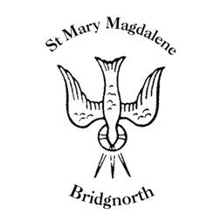

Sunday Services

Sunday 7th September
10.30am Holy Communion
Led by Revd. Simon Boxall

NEXT WEEK

Tuesday 9th September
12.00pm Funeral for the late Paul Smallman

Wednesday 10th September
10.30am Holy Communion
Led by Revd. Suzan Williams

7.00pm Comedy Night with Andy Kind

Thursday 11th September
10.00am Little Stars

Friday 12th – Monday 15th September
Glass Exhibition

www.bridgnorthteamministry.org.uk

