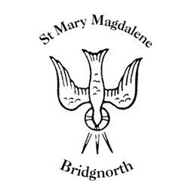

Sunday Services

Sunday 17th August
10.30am Morning Prayer
Led by David Oxtoby

NEXT WEEK

Tuesday 19th August
2.15pm Funeral of the late Maureen Mayes

Wednesday 20th August
10.30am Holy Communion
Led by Revd. Simon Boxall

Saturday 23rd August
10.00am Coffee Shop

www.bridgnorthteamministry.org.uk

