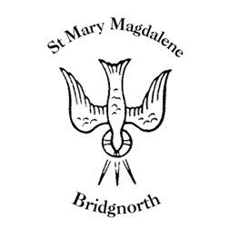

Sunday Services

Sunday 10th August
10.30am Holy Communion
Led by Revd. Suzan Williams

NEXT WEEK

Wednesday 13th August
10.30am Holy Communion
Led by Revd. Suzan Williams

Friday 15th August
6.30pm Bell-ringing to mark VJ day

Saturday 16th August
10.00am Coffee Shop

www.bridgnorthteamministry.org.uk

