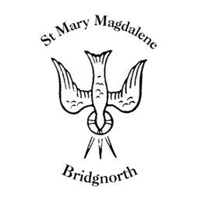

Sunday Services

Sunday 3rd August
10.30am Holy Communion
Led by Revd. Simon Boxall

NEXT WEEK

Wednesday 6th August
10.30am Morning Prayer
Led by Revd. Suzan Williams

Saturday 9th August
10.00am Coffee Shop

www.bridgnorthteamministry.org.uk

