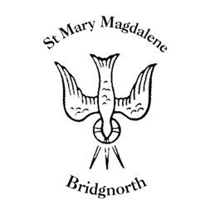

Sunday Services

Sunday 27th July
10.45am Baptism/Family Service
Led by Revd. Suzan Williams

3pm – 3.45pm District Bellringers practice

NEXT WEEK

Wednesday 30th July
10.30am Morning Prayer
Led by Roger Taylor

Saturday 2nd August
10.00am Coffee Shop

www.bridgnorthteamministry.org.uk

