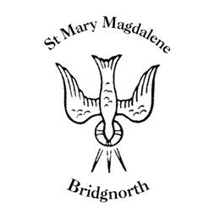

Sunday Services

Sunday 13th July
10.30am Holy Communion
Led by Revd. Suzan Williams

NEXT WEEK

Tuesday 15th July
A.M Bridgnorth Endowed visit

Wednesday 16th July
12.00pm Visiting bellringers – quarter peal

Thursday 17th July
10.00am Little Stars

Friday 18th July
510.00am St Marys Bluecoats service

Saturday 19th July
10.00am Coffee Shop
1.00pm Daddy’s Hat charity music event

www.bridgnorthteamministry.org.uk

