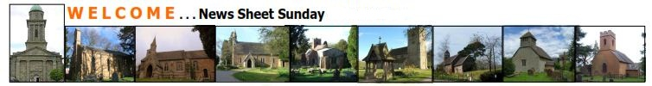

**Sunday 6th July 2025**



Linking the parishes of Bridgnorth, Tasley, Astley Abbotts, Oldbury,

Quatford, Morville, Aston Eyre, Acton Round, Monkhopton

**Office: St Leonards Hall Church, Racecourse Drive, Tasley, Bridgnorth WV16 4NR Tel: 01746 767174**

*open to personal callers—Mon 11-12.30,*

*Tue, Wed, Thu 8.30-11.30*

email [bridgnorthteamministry@yahoo.co.uk](mailto:bridgnorthteamministry@yahoo.co.uk)

**NEXT WEEK’S READINGS: Sun 13th July – Fourth Sunday After Trinity (Green): Colossians 1: 1-14, Luke 10: 25-37, Psalm 82.**

**Sun – July 13th**

10.00 Astley Abbotts – Café Church, Village Hall

10.00 Acton Round – Holy Communion

10.30 Aston Eyre – Morning Prayer

10.30 St Mary’s – Holy Communion

10.30 Tasley – Family Service

10.30 Quatford – Holy Communion

11.15 Morville – Morning Prayer

**Sun – July 20th**

9.00 Astley Abbotts – Morning Prayer

10.30 St Mary’s – Morning Prayer

10.30 Tasley – Holy Communion (St Leonards Hall Church to join)

10.30 Oldbury – Holy Communion

11.15 Morville – Morning Prayer

**Sunday 6th July**

**Third Sunday after Trinity (Green)**

**Sunday 6th July**

12.30 Welcome lunch for Vickie

St Leonards Hall Church

Tuesday 8th July

19.00 Bishop Richard chat

The Shakespeare Inn

Wednesday 9th July

19.00 Archdeacon visitation, St Marys

Church wardens to be sworn in.

Thursday 10th July

10.00 Little Stars

Saturday 12th July

10.00 Coffee Shop – St Mary’s

19.30 Bridgnorth Sinfonia

**GOOD Friday 7th April**

10 – 12noon Warm Hub St James HC

10.00 Walk of Witness from St Leonard’s HC

12.00 – 3.00 Good Friday Reflections St Mary’s

19.00 Easter Concert St Mary’s

|  |  |
| --- | --- |
|  |  |

**Wednesdays – St Mary’s - 10.30am - Holy Communion**

**Priest in Charge**: Revd. Suzan Williams, **Hon. Assistant Ministers**: Revd. Marjorie Brooks, Revd Simon Boxall, and **Anna Chaplain and Team Reader**: Jane Peeler

**St Mary’s Connect – Third Tuesday of the month–** at The Shakespeare Inn – for lunch and chat. If you would like to join us, please contact Catherine Wilson on 01746 761786 to book a place**– Next date we will meet is Tuesday 15th July.**

**Anna Chaplaincy Talk Thursday 10th July at 7pm, All Saints Church Hall, Broseley.** Please contact Jane for more details.

**Commissioning of Local Worship Leaders Sunday 13th July at 4pm, Astley Abbotts.**

**The Art of Imitation Vocal Ensemble Concert Monday 21st July 7.30pm at St Mary’s.** £10 tickets from [www.ticketsource.co.uk](http://www.ticketsource.co.uk) or go to the team ministry website ‘upcoming events’ page for the ticket link.

**Film Club – Thursday 24th July 7th & 14th August. 10am-1pm at St James Hall Church** – come along for some crafts, games, watch a film and enjoy a meal together. Contact Suzan for more details & for catering purposes: [rectorbridgnorthandmorville@gmail.com](mailto:rectorbridgnorthandmorville@gmail.com) or tel: 01746 588528

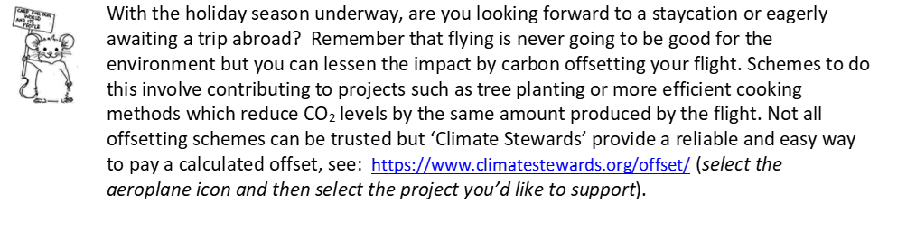

**POST COMMUNION**

O God, whose beauty is beyond our imagining

and whose power we cannot comprehend:

show us your glory as far as we can grasp it,

and shield us from knowing more than we can bear

until we may look upon you without fear;

through Jesus Christ our Saviour. Amen.

**COLLECT**

Almighty God,

you have broken the tyranny of sin

and have sent the Spirit of your Son into our hearts

whereby we call you Father:

give us grace to dedicate our freedom to your service,

that we and all creation may be brought

to the glorious liberty of the children of God;

through Jesus Christ your Son our Lord,

who is alive and reigns with you,

in the unity of the Holy Spirit,

one God, now and for ever. Amen.

**GALATIANS 6: 1-16** My friends, if anyone is detected in a transgression, you who have received the Spirit should restore such a one in a spirit of gentleness. Take care that you yourselves are not tempted. Bear one another’s burdens, and in this way you will fulfil the law of Christ. For if those who are nothing think they are something, they deceive themselves. All must test their own work; then that work, rather than their neighbour’s work, will become a cause for pride. For all must carry their own loads. Those who are taught the word must share in all good things with their teacher. Do not be deceived; God is not mocked, for you reap whatever you sow. If you sow to your own flesh, you will reap corruption from the flesh; but if you sow to the Spirit, you will reap eternal life from the Spirit. So let us not grow weary in doing what is right, for we will reap at harvest time, if we do not give up. So then, whenever we have an opportunity, let us work for the good of all, and especially for those of the family of faith. See what large letters I make when I am writing in my own hand! It is those who want to make a good showing in the flesh that try to compel you to be circumcised—only that they may not be persecuted for the cross of Christ. Even the circumcised do not themselves obey the law, but they want you to be circumcised so that they may boast about your flesh. May I never boast of anything except the cross of our Lord Jesus Christ, by which the world has been crucified to me, and I to the world. For neither circumcision nor uncircumcision is anything; but a new creation is everything! As for those who will follow this rule—peace be upon them, and mercy, and upon the Israel of God.

**LUKE 10: 1-11, 16-20**

After this the Lord appointed seventy others and sent them on ahead of him in pairs to every town and place where he himself intended to go. He said to them, ‘The harvest is plentiful, but the labourers are few; therefore, ask the Lord of the harvest to send out labourers into his harvest. Go on your way. See, I am sending you out like lambs into the midst of wolves. Carry no purse, no bag, no sandals; and greet no one on the road. Whatever house you enter, first say, “Peace to this house!” And if anyone is there who shares in peace, your peace will rest on that person; but if not, it will return to you. Remain in the same house, eating and drinking whatever they provide, for the labourer deserves to be paid. Do not move about from house to house. Whenever you enter a town and its people welcome you, eat what is set before you; cure the sick who are there, and say to them, “The kingdom of God has come near to you.” But whenever you enter a town and they do not welcome you, go out into its streets and say, “Even the dust of your town that clings to our feet, we wipe off in protest against you. Yet know this: the kingdom of God has come near.”

‘Whoever listens to you listens to me, and whoever rejects you rejects me, and whoever rejects me rejects the one who sent me.’ The seventy returned with joy, saying, ‘Lord, in your name even the demons submit to us!’ He said to them, ‘I watched Satan fall from heaven like a flash of lightning. See, I have given you authority to tread on snakes and scorpions, and over all the power of the enemy; and nothing will hurt you. Nevertheless, do not rejoice at this, that the spirits submit to you, but rejoice that your names are written in heaven.’

**PSALM 30**

I will extol you, O Lord, for you have drawn me up, and did not let my foes rejoice over me. **O Lord my God, I cried to you for help, and you have healed me**. O Lord, you brought up my soul from Sheol, restored me to life from among those gone down to the Pit. **Sing praises to the Lord, O you his faithful ones, and give thanks to his holy name.** For his anger is but for a moment; his favour is for a lifetime. **Weeping may linger for the night, but joy comes with the morning.** As for me, I said in my prosperity, ‘I shall never be moved.’ **By your favour, O Lord, you had established me as a strong mountain; you hid your face; I was dismayed.** To you, O Lord, I cried, and to the Lord I made supplication: ‘**What profit is there in my death, if I go down to the Pit? Will the dust praise you? Will it tell of your faithfulness?** Hear, O Lord, and be gracious to me! O Lord, be my helper!’ **You have turned my mourning into dancing; you have taken off my sackcloth and clothed me with joy,** so that my soul may praise you and not be silent. O Lord my God, I will give thanks to you for ever. **Glory to the Father and to the Son and to the Holy Spirit as it was in the beginning is now and shall be forever. Amen**.