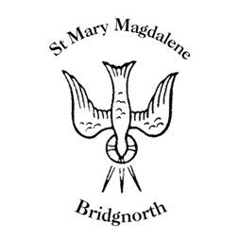

Sunday Services

Sunday 22nd June
10.30am Morning Prayer
Led by David Oxtoby

NEXT WEEK

Thursday 26th June
10.00am Little Stars
6.30pm Talk by Simon & Sarah Cawdell
(Church Mission Society, Uganda)

Friday 27th June
12pm Funeral for the late Mr Robert Groom

Saturday 28th June
10.00am Coffee Shop

Sunday 29th June
6pm Service of Remembrance

www.bridgnorthteamministry.org.uk

