THE PARISH CHURCHES
PARISH OF BRIDGNORTH

Church of St Mary Magdalene:
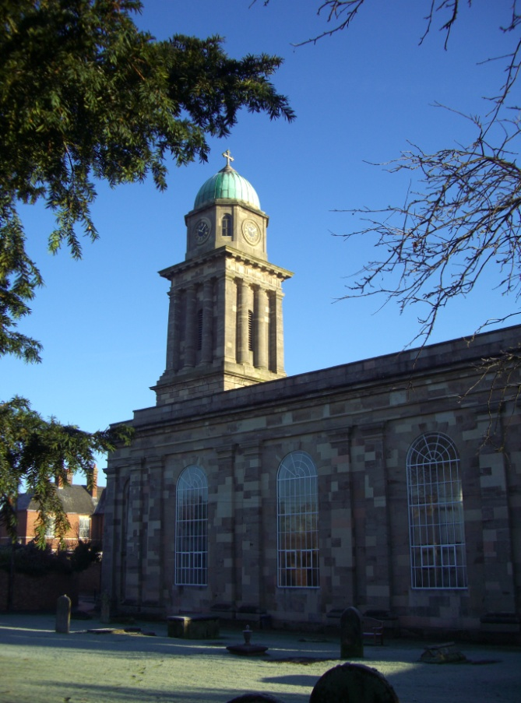
The first Norman Castle chapel dedicated to St Mary Magdalene was built at the turn of the twelfth century when Bridgnorth was chosen by the Norman Robert de Belesme who was charged with the control of the Welsh Marches, and was part of the fortified stronghold established on the end of the sandstone outcrop at Bridgnorth.
The Norman castle was held by the Royalists during the Civil War, and was finally taken and destroyed by the Parliamentarians in 1645.

The present St. Mary Magdalene, designed by Thomas Telford and consecrated in 1796, and is a Grade II* listed building; and the church is unusual in so far as it is oriented north south, as this Telford church is much larger than the original castle church which it replaced. Current seating is for 377.

The 1796 church was extended in the late 19th century when a chancel and sanctuary was added, along with Victorian pews. The church has recently been redecorated and is in good repair and has both kitchen and toilet facilities. A Father Willis organ was installed in 2008, and the church now has a magnificent organ which is used for worship and it strengthens St Mary’s long tradition for musical and choral excellence, and is often used for concerts and other community uses. Currently the church is applying for grants for the replacement of the raised timber floors, which are deteriorating due to fungal and worm attack, work which it is hoped will be undertaken in the next 24 months, and part of the vision behind this is to expand community usage of this landmark site.

The town was also served by St Leonard’s church, the first church being built in thirteenth century and situated in the centre of town. This building was used by the Parliamentary Forces during the civil war. St Leonard’s was damaged during the war, and had various rebuilds until it was finally declared redundant in the mid 1970’s due to rising maintenance and repair costs, and is now in the care of the Churches Conservation Trust. Selected services are still held there, the main being the annual Remembrance Service in November and the building is also used for local exhibitions, fairs and community functions. It is a vast building which seats almost 800.

In addition there are two Hall Churches which are used for worship and local community activities: St Leonard’s Hall is close to Tasley and houses the Team Office; St James Hall Church is located across the River Severn in Low Town. These are featured below.

The People
The church caters for all ages and provides for children including Sunday school.

Little Stars meets weekly on Thursdays during term time for preschool children and their carers and is a ministry of crafts and chat in an informal atmosphere. We have had a number of baptisms through it, and signpost families of infants being baptized to it.

Other groups include MU, Ladies Group, and House Groups/Courses.

The Friends of St. Mary’s arrange social and fund raising events, and there is a monthly fellowship group which meets for lunch at various restaurants in the town catering for those who don’t get out often

St Mary’s has an excellent musical life with a Musical Director and Organist, an assistant organist, a robed adult choir and a large and dedicated group of Choristers. The church is host to many musical events and concerts throughout the year and recently had a Father Willis organ installed.

There is a healing ministry team which staffs morning services. .There is a Team of Bell Ringers and Servers who are regularly on duty.

The hospital is also a key focus of ministry, together with schools and residential homes. Lay people are involved in this and other areas of pastoral ministry.

Finances
Parish Share is paid in full although this sometimes involves drawing on reserves.

The Statistics
Electoral Roll =175
Average Attendance = 75

The Services
The church offers a variety of forms and styles of worship.

Sunday services:
8.00am: Holy Communion – said (BCP 2nd & 4th Sundays)
10.30am: Sung Communion (4th Sunday – Family service with baptism (when relevant), 5th Sundays – Family Communion)
12.15pm: Baptisms (1st & 3rd Sundays)
6.30pm: Choral Evensong

Other Sunday services in the parish:
10.30am: St Leonard’s Hall (1st Sun. Family Service, 3rd Sun Family Communion)
4.00pm: Hospital Communion
7pm: St. James Hall Church (4th Sunday Praise & prayer – Acoustic worship, prayer and prophetic ministry)

Mid Week
8.45am Morning Prayer (except Fridays)
Wednesday: 10.30am: BCP Holy Communion – said
Blessing prayer: 7.30pm 1st & 3rd Tuesdays (A ministry of prayer and blessing for the community based on the model of Ffald Y Brenin)
Little Stars: Thursday 9.30am during term time

The Hall Churches

St. Leonard’s Hall Church
St. Leonard’s Hall Church was built in the 1970s and is extensively used by the community for clubs, societies and parties. It earns a good rental income and is well maintained. It is also the site of the Team Office during the week and is a familiar venue to its local community situatied on the boundary between Tasley and Bridgnorth.

Since it was built it has been the venue for a church community specialising in informal family services which has been led by two church members for over 25 years. It has a twice monthly attendance of around 20 (althugh this has never been formally recorded) which also forms a house group meeting on the alternate weeks. As well as these services they also hold periodic suppers with a mission flavour to them which are well received.

There is scope to develop this buildng on the present congregation to outreach to the local population in a style very different from St. Mary’s Church in the centre of the town, and this was not in any sense be seen as a conflicting mission.

St. James Hall Church
St. James Hall Church was built in the late 1950s on the Grove Estate, then one of the more socially deprived areas of the town, and rapidly became a much loved focus of the community.

Fifty years on it had become very delapidated, even to the point where sale had been considered. By the grace of God and hard work of a dedicated group a number of significant grants became available and three years ago the hall underwent a complete refurbishment at a cost of just under £250k. This has led to a complete revival of the Hall as a community venue, andi s now a top class resource for the church’s mission including inbuilt AV resources and fully equipped commercial kitchen. It accomodation includes a main hall and two smaller meeting rooms.

The only service held there regularly at present is a monthly Praise and Prayer meeting which is very charismatic and prophetic in style, and is led by john Prockter of BYSP with acoustic worship, and The Rector.

It is the venue for St. James Youth and would make a fantastic venue for a youth church as time progresses orinformal worship for the surrounding community. It is not oten a church can offer a blank canvass to be filled, but this is a rare opportunity that is just that.

PARISH OF OLDBURY WITH EARDINGTON

The Church of Saint Nicholas
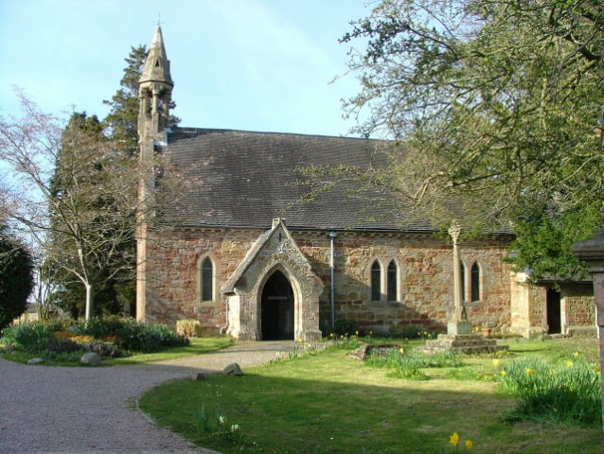
The church is situated in the small village of Oldbury on the outskirts of Bridgnorth. Originally a daughter church of Morville, it became independent after the dissolution of Shrewsbury Abbey. There has been a church on the site since the 12th century, first recorded in 1138. It is largely the product of a Victorian restoration. In 1948 it joined with St Mary Magdalene, Bridgnorth. It is a small attractive church with limited kitchen facilities added in 1993. The church has good parking facilities for up to 40 cars.

The People
The parish of Oldbury also serves the neighbouring village of Eardington and two estates on the edge of Bridgnorth. Eardington does not have a church, but church members do organise occasional events at the Village Hall, which is sometimes used for fund raising activities. There is a lively social programme which brings people together and raises funds for the church. In recent times the church has held wedding shows, a quilting exhibition, and during the present commemorations of the First World War is working closely with the local secondary school to host commemorations of significant events using local records and historical resources.

The church is often seen as a ‘wedding’ church being a good size for up to 100 in a pretty location and excellent parking facilities. There is a vision for installing a fully operational kitchen and toilet facilities to replace the present limited arrangements. Relationships with the local community are excellent and the congregation wish to work through how this can be followed through into faith development.

Finances
The parish share is paid in full. Finances are boosted by fund raising activities.

The Statistics
The Electoral Roll has =54
Average attendance =22

The Services
1st Sunday: ‘Life & Soul’ & Baptism if needed.
2nd – 4th Sunday Holy communion

All services include hymns.

The church is fortunate to have the services of an excellent organist who also leads the Quatford and Oldbury choir. The choir sings at special events in the church calendar.

PARISH OF ASTLEY ABBOTTS
The Church of St Calixtus
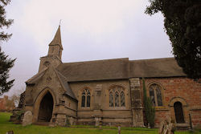
The Church of St Calixtus is situated 3 miles out of Bridgnorth, just off the Bridgnorth to Broseley Road. It is a small hamlet set in an idyllic village setting with a small stream running alongside the churchyard. The hamlet has recently increased with the addition of new housing. The church was consecrated in 1138 by Bishop Betton. It is mainly Norman with Anglo-Saxon roots, with Roman tufa stone found in the walls. A later addition was built during the mid 1800’s. The church is in good condition. There are no other church buildings but a village hall is used for church community functions.

The People
The church community in Astley Abbotts consists of a fair range of ages, and considerable effort is made to advertise family services. There is faithful support for all services and events within the Parish and the church is particularly well attended at major festivals. The friends of St Calixtus, a community group, successfully undertake fundraising for the fabric of the building. The church works with the community to hold various social events throughout the year including concerts and open gardens. The Church is a focal point in the village, which is reflected in the care given to the churchyard and interior.

The Finances
The parish is paid in full.

The Statistics
Electoral Roll =56
Average Attendance =13

The Services
1st Sunday 9.00am BCP Communion
2nd Sunday 9.30am Family Service (Lay Led)
3rd Sunday 9.00am CW Communion
4th Sunday 9.00am Morning Prayer
5th Sunday 9.00am CW Communion

All services include hymns. The parish has an excellent organist shared with Tasley.

PARISH OF QUATFORD

Church of St Mary Magdalene
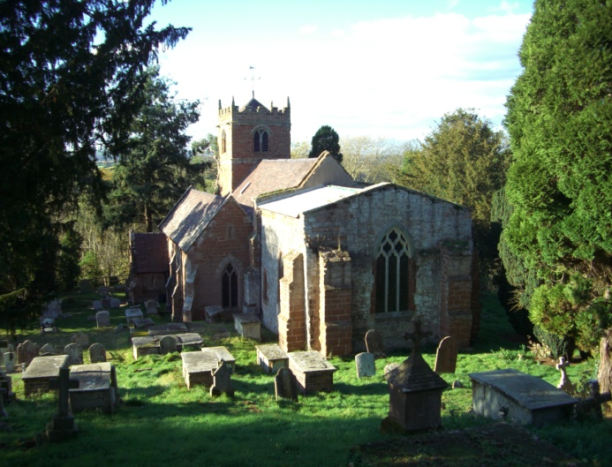
The church of St Mary Magdalene is approximately 3 miles from Bridgnorth on the A442 to Kidderminster. It was built in 1086 (on the promise of love). It was the site of the first Parish Church until it was replaced by the building of the church in Bridgnorth. The church is constructed of sandstone and tufa. It is in good repair, and has recently undergone an internal reordering to enable nave celebrations of communion as the chancel altar is quite remote to the nave. Nearly 40 steps lead up to the church. Installed in 2005, an electrically powered lift enables the disabled (or tired!) access. There is presently a plan to further enhance church facilities with the installation of a toilet and kitchen facilities. This is the subject of grant applications at present.

The People
A small but faithful congregation is made up of mainly retired people. There are regular social activities held working with the local community, and there are four park home developments within the parish centred around the church. One of these is owned by the Quatford Churchlands Trust, and generates income to support the repair of the church ‘and other uses.’
Most of the congregation live in the town, not the village. The parishes of Quatford and Oldbury combine to form an excellent choir which sings at special services and for various social and fundraising events.

The Finances
The parish share is paid in full.

The Statistics
Electoral Roll = 51
Average Attendance = 15

The Services
9.00am 1st 3rd, 4th, 5th Sunday: CW Communion
2nd Sunday: BCP Communion,
All services include hymns. The church is fortunate to have services of an excellent organist who also leads the choir.

PARISH OF TASLEY
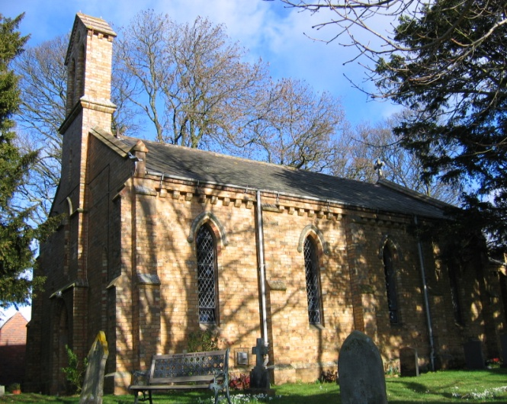
Church of St Peter and St Paul
The Church of St Peter and St Paul is set in a semi rural position on the west side of Bridgnorth. It is built of local brick and was constructed in 1840 and seats 90/100. It is in good overall condition. There has been a church on this site since 1138. There are no other church buildings but all church fund raising events are held in the Village Hall.
The churchyard is set in a beautiful location and is popular and much visited. The PCC have been delighted to restore the bells to ringing condition this year for the first time in a hundred years.

The People
There are a few dwellings and farms nearby but the bulk of the Parish is separated from the church. This includes housing estates built in the 1990’s and a new development of 310 houses built in the last five years (40% of which is social housing). The Parish sees as an opportunity for the development for mission and has made significant efforts to contact new occupants. It has seen considerable liturgical change over the last five years as it has sought to become more accessible to the local community, and this has included the very successful introduction of monthly family services.
The Parish enjoys social and fund raising events during the year and the PCC meet five times a year.

Finances
The parish share is paid in full.

The Statistics
Electoral Roll =54
Average Attendance = 24

The Services
The Parish offers services based on the Book of Common Prayer
1st 3rd and 5th Sundays: Holy Communion
2nd Sunday Family Service
4th Sunday: Morning Prayer - Sung
All services at 10.30 am
Sung Evensong for Patronal Festival at 6.30pm.
All services include hymns, the Parish has its own Organist and vestments are worn.

PARISH OF MORVILLE

Church of St Gregory the Great.
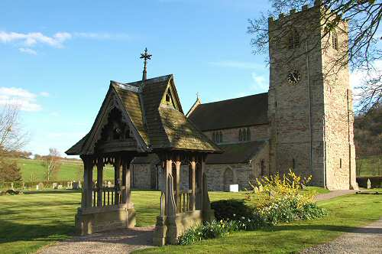
The Church is set in a totally rural setting, within an enclosed area, in a field and includes car park and approached by driveway. The building was completed in 1118 and retains almost all of the original Norman features and was constructed within the precincts of a Priory establishment. This was destroyed in 1540, leaving the church as the Parish place of worship.
The interior presents a warm and friendly atmosphere, that being adjacent to National Trust buildings, attracts many visitors. Recent major construction projects have seen three phase electricity, enabling Quartz Halogen heating to be added to give an acceptable comfort level and in 2009 a redesigned Vestry, in the base of the tower provided toilet and kitchenette facilities. The same year saw the retuning and additional bells re-swung, within an upgraded ringing chamber.

The People
The Parish draws on a village support of around 275 to which outlying farm and hamlets add another 100. The church enjoys the benefit of active fund raising and other voluntary support. The Church annual fete is a high point of the year in the community and attracts several hundred people from across the area. The PCC works closely with residents of Morville Hall and its surrounding buildings on the several opens days in the year to provide teas. Cooperation with and participation from the C of E Primary school, together with activity groups using the modern Village Hall, greatly encourages a busy and self sufficient community which has the church at its heart.

Finances
The parish share is paid in full:

Statistics
Electoral Roll =32
Average attendances =12

Services
The Parish offers services based on the BCP.
1st. Sunday: Communion.
2nd Sunday: Sunday School and Family Service.
3rd Sunday: Communion.
4th Sunday: Family Service.
5th.Sunday: Healing Service.
St. Gregory’s has its own organist and all services include hymn accompaniment.

PARISH OF ASTON EYRE
Church at Aston Eyre
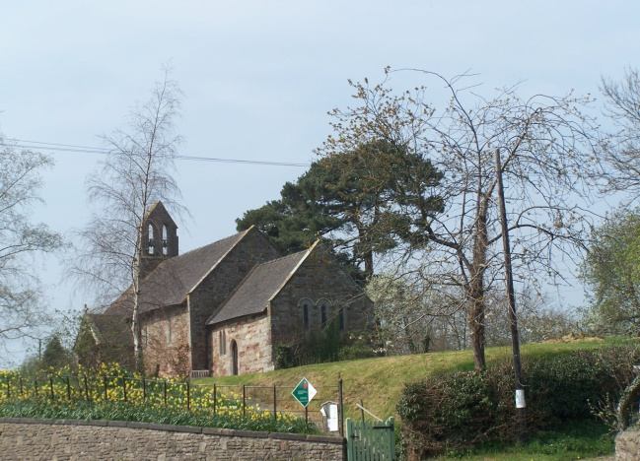
Aston Eyre is probably the newest parish in the Church of England! It was created out of the parish of Morville on 29th Feb this year. The church has no dedication but a carving of the Procession of Palms over the entrance makes it apporpiate to celebrate Pal Sunday as its Partronal. The church was built in 1132 for the owners of Aston Hall which was converted to agricultural use in the 18th century and is now a ruin. The church sits in the centre of this small hamlet.

The church building is in good shape as was confirmed in the recent Quinquennial report. A review of the access for disabled people has been carried out. There has never been a graveyard but for the last ten years the flower bed at the East end of the church has been available for strewing ashes. Vehicle access to the church is with permission to use the drive belonging to the owners of Church House. Pedestrian access is up steps from the road. The PCC employ a parishioner on a casual basis to keep the churchyard tidy and members of the PCC mow the grass.

The People
There are some twenty four households with about 50 adults and 9 children. This rural parish has five working farms (not all the owners live in the village) and two smallholdings. The hamlet is five miles from Bridgnorth. There is an excellent primary school in Morville one mile away.

Finances
The parish share is paid in full and recently the PCC volunteered to increase their contributions to the diocese by 50%.

Statistics
Electoral Roll =13
Average attendance =10

Services
2nd Sunday: 10.00am Holy Communion
4th Sunday: 10.00am Morning Prayer

PARISH OF ACTON ROUND

Church of St Mary the Virgin
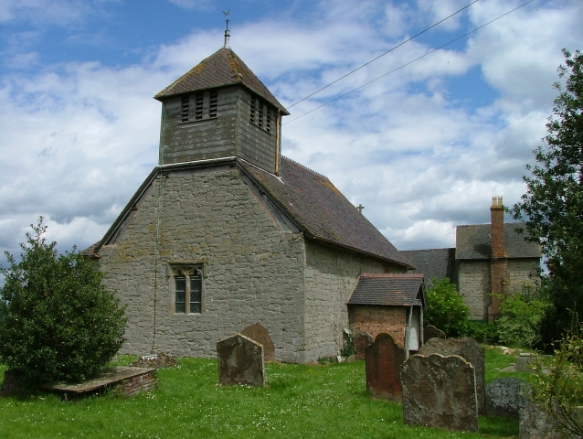
The Church consists of a predominantly Norman nave, C14th chancel and a timber framed belfry containing two ancient bells. In the C18th a mortuary chapel was added on to the north wall which contains a fine monument to Sir Whitmore Acton and his wife by Thomas Farnolls Pritchard the designer of “The Iron Bridge”. Above the south door is a thoroughly modern monument, designed in the shape of a Norman Tympanum, which depicts the present day parishioners going about their daily business.

At the time of the 2001 census the population of Acton Round was 85 which is about half of what it was in 1841. It is and always has been a farming community, with very little industry, although recently a number of business units have been built on the site of the old filling station at Muckley Cross. Many of the families living and working in the parish have been there for generations and perusal of the old census returns will show names which are still very much in evidence today. There is no school, no pub, no post office and no shop. Although the main A458 runs through the middle of the parish the majority of the parishioners live along the small, unmarked lanes which run off it. The local children, of which there are around 20, attend the church primary school in Morville or the secondary schools in either Bridgnorth or Much Wenlock. Members of the parish serve as school governors and parish councilors.

Although small the parish is a friendly and united community with the church at its heart. As well as monthly services of Holy Communion it hosts regular concerts for the world renowned Haydn Festival. In recent years there have been flower festivals, poetry and book readings, a talk on the history of the parish and many visits by local history societies.

Finances
The parish share is paid in full.

Statistics
Electoral Roll =16
Average attendance =10

Services
2nd Sunday: 10.00am BCP Holy Communion

PARISH OF MONKHOPTON WITH UPTON CRESSETT

The parish is known as Monkhopton with Upton Cressett. Access between the two is only a cart track and the direct road (very narrow lane!) to Upton Cressett is from Morville.

MONKHOPTON-Church of St Peter’s
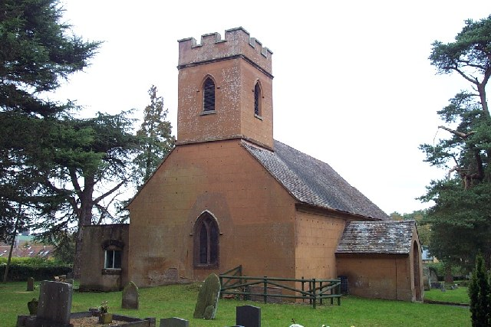
This 12th century church grade 2* serves a small hamlet of 86 people. It has recently been significantly renovated through the hard work of a dedicated local group of parishioners. The church is heated and it and the churchyard is well maintained. The land is all within one estate but is rented out to other farmers. It is about six miles west of Bridgnorth, the nearest shopping centre. Parishioners use the GP practices in Ditton Priors and Bridgnorth. The children attend primary schools in Ditton Priors, Brockton, Morville and Bridgnorth and move on to one of the two secondary schools in Bridgnorth.

People
Predominantly the parish (Population 2001=183) is very rural with many scattered farms. No shop, pub or post office, but there is an Old People's Home. There is no village hall or community focal point, but church members are closely involved with community and fundraising events held in Morville. The group responsible for restoring he church are also key to the recent revival in church attendance, which had almost dwindled to nothing five years ago. Festival services are very well supported with anything up to 50 people joining in from across the community.

Finances
Parish share is paid in full

Statistics
Electoral Roll 16
Average attendance 9

UPTON CRESSETT-Church of St Michael's
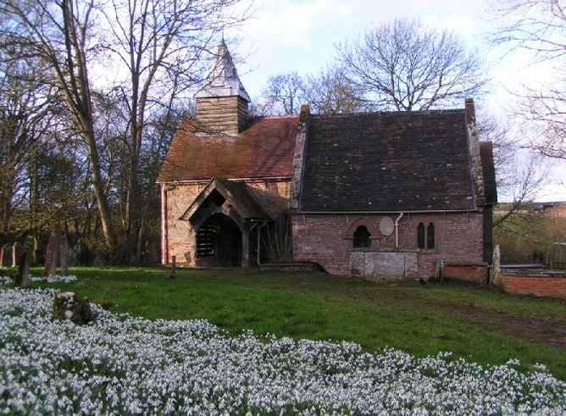
St Michael’s Church stands in the grounds of Upton Cressett Hall. Originally 12th century, but largely rebuilt in mid 19th century
it is in the care of the Churches Conservation Trust. Occasional services are held there by arrangement with the Rector.

